Outpute

#### -Home page:

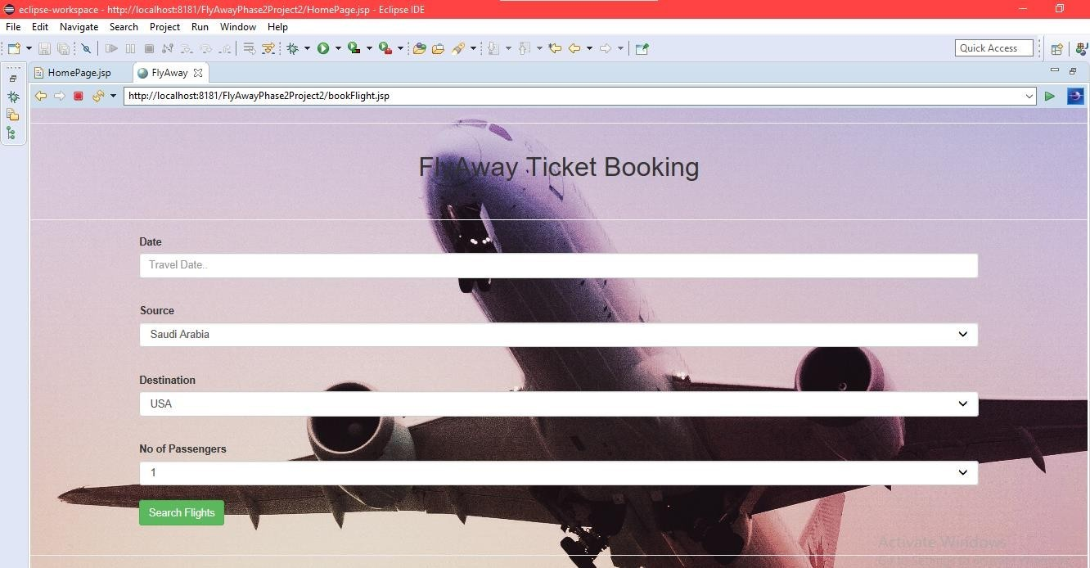**-book a flight page:**

#### -search result page:

#### -the passenger details page:

#### 

#### -payment page:

#### -ticket summary page :

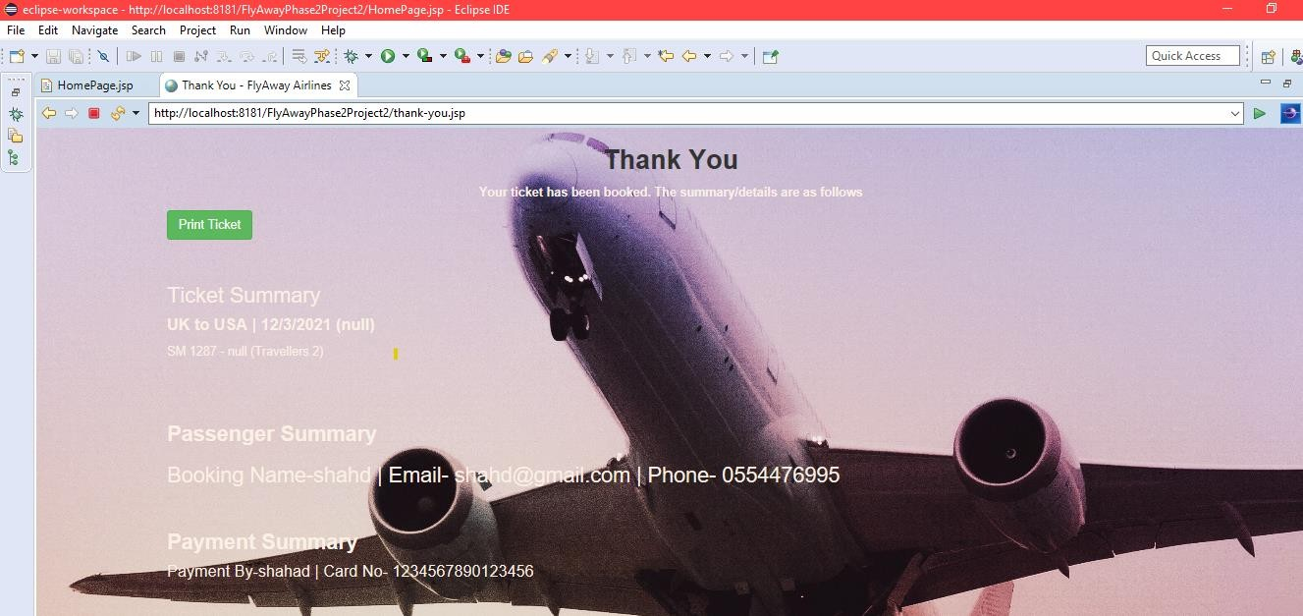

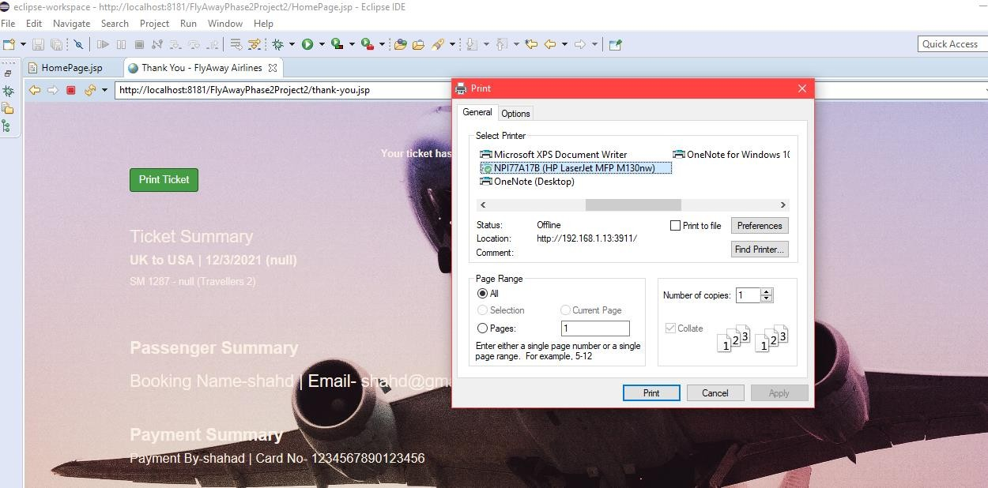 Passengers can print their ticket if they wishes By clicking on the print ticket button

#### -Admin login page

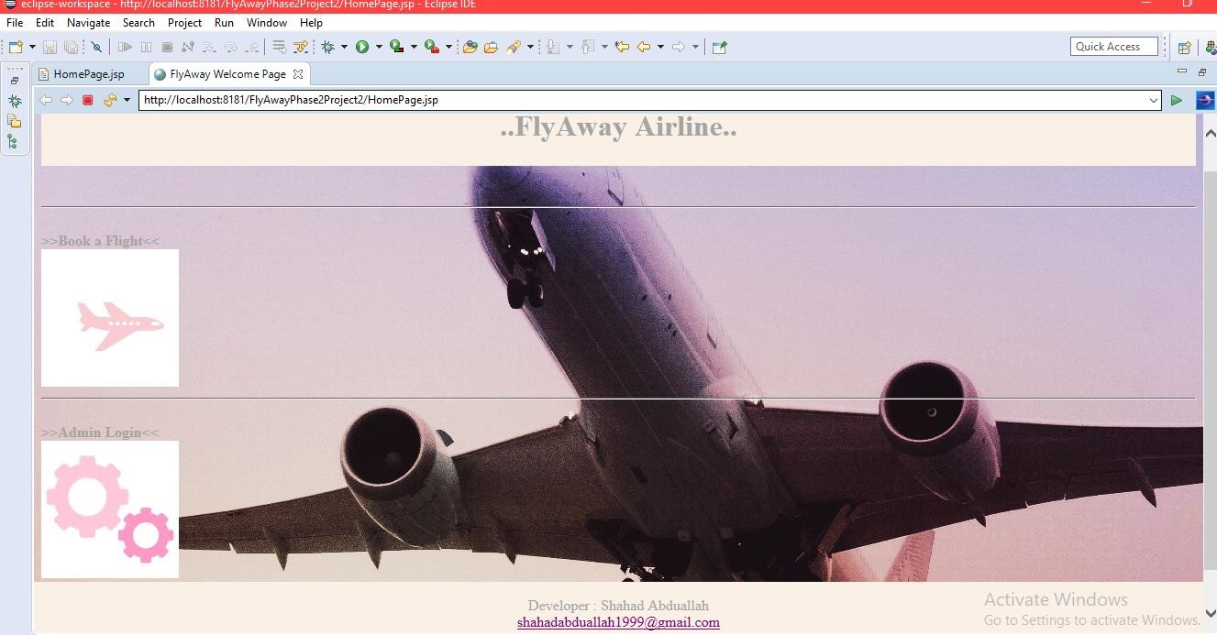

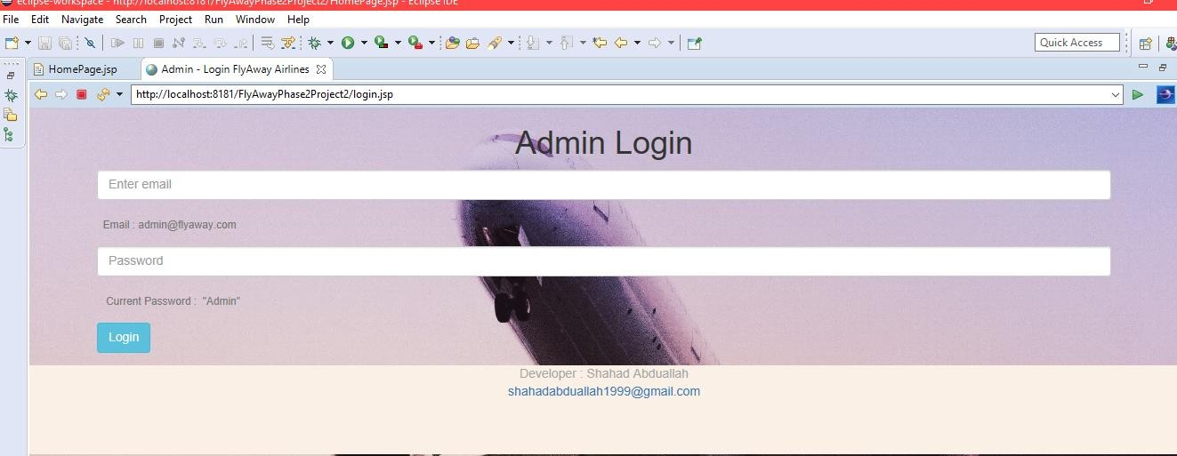

If the user enters Incorrect Email or Password this window will show up.

### 

### صورة تحتوي على نص تم إنشاء الوصف تلقائياً

### **-Admin dashboard**

